
Regulations:
A12
Sreenidhi Institute of Science and Technology
(An Autonomous Institution)
Code No: 3A820 Date:24-May-16
B. Tech. IV-Year II-Semester Examinations, May 2016 (Regular)
ELECTRICAL DISTRIBUTION SYSTEMS (EEE)

Time: 3 Hours Max. Marks: 70

Note: No additional answer sheets will be provided.

Part - A
Max.Marks:20

Answer all QUESTIONS. EACH QUESTION CARRIES 2 MARKS.
- The annual peak load of a feeder is 2500 kW; the total copper loss is 100kW per three-phase. Assuming an annual loss factor of 0.2, determine
i) the average annual power loss.
ii) total annual energy loss due to the copper losses of the feeder circuits.
- Define connected load and diversity factor.
- Write the advantages and disadvantages of radial type primary feeder.
- What are the different voltage levels in electrical distribution system?
- Discuss about secondary mains.
- Write the factors affecting primary feeder voltage levels.
- Define service voltage.
- What is load break switch?
- A 24kV, single-phase circuit feeds a load of 360kW at a lagging load power factor and load current is 200 A. If it is desired to improve the power factor, determine
i) uncorrected power factor and reactive load
ii) new corrected power factor after installing a shunt capacitor with a rating of 300kVAr.
- List out the objectives of distribution system protection.

Part – B
Max.Marks:50

ANSWER ANY FIVE QUESTIONS. EACH QUESTION CARRIES 10 MARKS.

- Derive the relationship between the load and loss factors for three different cases when
i) off-peak load is zero
ii) load is steady
iii) for very short lasting peak

- a) Derive the voltage drop and power loss equations for a radial primary feeder with uniformly distributed load. (6M)
b) Explain the factors affecting conductor size selection. (4M)

- a) Explain the factors affecting location of substation. (4M)
b) Explain how the rating of distribution substation can be calculated. Explain taking a general case with ‘n’ no.of feeders. (6M)

4. The three-phase four-wire 415V secondary system with balanced per-phase loads at A,B and C are shown in fig.1. Determine the following:
i) Calculate the total Voltage drop.
ii) Calculate the real power per phase for each load.
iii) Calculate the reactive power per phase for each load.
iv) Calculate the total(three-phase) kVA out put and load power factor of the distribution transformer.
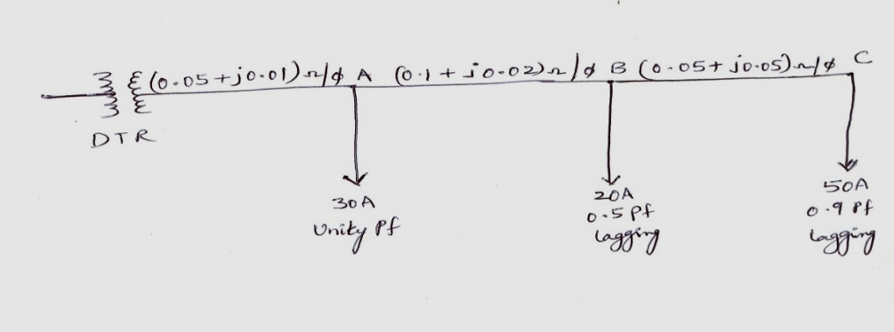
Fig.1

5. a) Explain about Recloser-to-Recloser coordination.
b) Explain the operation of Automatic circuit Breaker.

6. a) Give the list of Voltage control methods.
b) Assume that a substation has a bank of three 2000 kVA transformers that supplies a peak load of 7800 kVA at a lagging power factor of 0.89. All three transformers have a thermal capability of 120% of the nameplate rating. it has already been planned to install 1000 kVAr of shunt capacitors on the feeder to improve the voltage regulation. Determine.
i) Whether or not to install additional capacitors on the feeder to decrease the load to the thermal capability of the transformer.
ii) The rating of the additional capacitors.

7. a) A three-phase 4.16kV star grounded 500km long feeder main has a K constant of 0.0001
VDpu/kVA-km. Determine the percent voltage drop if the load is
i) 500 kVA uniformly distributed load.
ii) 250 kVA increasing load .
b) Explain how increase in service area and addition of new feeders effect the percentage voltage drop.

8. a) Explain the practical procedure to determine the best capacitor location.
b) Explain about step-type voltage regulators.

-- 00 -- 00 --

